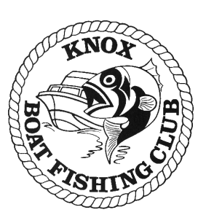 | KBFC Whiting Event  Rules-of-the-Day

Date: Sunday 8th December 2019

Venue: Port Phillip

Sponsors: N/A

Communication:
ON WATER VIA VHF Ch 77, 27 MHZ Ch 96 OR MOBILE PHONE
Weigh Masters(s):
Ken Barton K107 M: 0418 306 126

Recorder:
Photos to John McGregor K73 M: 0410 342 434
A KBFC official measuring ruler must be used (total length to tip of tail)
Submit one photo of your longest capture by end of the event – 5.30 pm Saturday
Ensure photo is clear and K number is included in message

Weigh In: Length only
Sunday - 3.30 pm

Lines down:
Sunday - 5.30 am

Trevor Smart Trophy
Heaviest weighed snapper over the season will be eligible for the Trevor
Smart Trophy

Specific Rules:

- Sunday 8th December is a single event
- Event point scoring for the KBFC annual angling trophies will be calculated as follows:
  - Longest Whiting = 4 Points
  - 2nd Longest Whiting = 3 Points
  - 3rd Longest Whiting = 2 Points
- All members presenting photos of a whiting measurement to the recorder and do not qualify for 1st, 2nd or 3rd will receive one participation point
- All fish presented for weigh in must meet the requirements specified in the acceptable species list
- Except for Intermediate and Junior divisions where minimum legal size applies.

Species | Club/Senior length | Legal/Intermediate/Junior
King George Whiting | 30cm | 27cm

Contact Weigh master of the day for cancellations or restrictions.
Automatic cancellation will occur if a “strong wind warning” is issued one hour before lines down.
Special Conditions Regarding Event Entry
The holding of this Angling Event is not to be construed as an invitation to go to sea or to take to the water in conditions beyond the capability of craft and crew.
Only Vessels covered by third party insurance for property and personal liability (“insurance”) are eligible to participate in this Angling Event. The Skipper is to ensure that the Vessel used in this Angling Event is covered by insurance as required.
All Competitors must abide by all rules pertaining to Angling Event.
Participation in the Angling Event is at a person’s own risk and the Club, the Executive Committee and Event Weigh masters are released and indemnified from any liability whatsoever occurring as a result of participation in this Angling Event.

