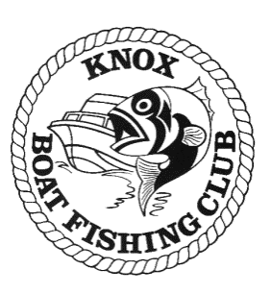 | KBFC Nightmoves  Snapper Event  Rules-of-the-Day

Date: Friday 29th November 2019

Venue: Carrum

Sponsors: N/A

Communication:
ON WATER VIA VHF Ch 77, 27 MHZ Ch 96 OR MOBILE PHONE
Weigh Masters(s):
Ken Chandler K170 Mob: 0409 966 620

Weigh In: Weight only
10.30 pm at Patterson Lakes Boat Ramp No 3

Lines down:
3.00pm

Trevor Smart Trophy
Heaviest weighed Snapper over the season will be eligible for the Trevor
Smart Trophy

Stan Watts Shield – (Heaviest weighed fish over all nightmoves)
Heaviest weighed fish over the season will be eligible for the Stan Watts Shield

Specific Rules:

- Friday 29th November 2019 will be a single event, with point scoring for captures presented at the weigh in.
- All fish presented for weigh in will be measured by weight only.
- Event point scoring for the KBFC annual angling trophies will be calculated as follows:
  - 1st Place - Heaviest Snapper = 4 Points
  - 2ndPlace - Heaviest Snapper = 3 Points
  - 3rd Place - Heaviest Snapper = 2 Points
- All members attending weigh in will receive 1 participation point.
- All fish presented for weigh in must meet the requirements specified in the “Acceptable Species List”
- Except for Intermediate and Junior divisions where minimum legal size applies.

Species | Club/Senior length | Legal/Intermediate/Junior
Snapper | 35cm | 28cm

Contact Weigh master of the day for cancellations or restrictions.
Automatic cancellation will occur if a “strong wind warning” is issued one hour before lines down.

Special Conditions Regarding Event Entry
The holding of this Angling Event is not to be construed as an invitation to go to sea or to take to the water in conditions beyond the capability of craft and crew.
Only Vessels covered by third party insurance for property and personal liability (“insurance”) are eligible to participate in this Angling Event. The Skipper is to ensure that the Vessel used in this Angling Event is covered by insurance as required.
All Competitors must abide by all rules pertaining to Angling Event.
Participation in the Angling Event is at a person’s own risk and the Club, the Executive Committee and Event Weigh masters are released and indemnified from any liability whatsoever occurring as a result of participation in this Angling Event.

